ctFIRE Beta Version 1.1 Users Manual

Main Developers:  Yuming Liu, Jeremy Bredfeldt

April 22, 2013

1 Introduction 1

2 GUI control panel 2

3 Tutorial 4

3.1 Step 1: open images 4

3.2 Step 2: set input and output parameters: 4

3.3 Step 3: run 4

3.4 Step 4: check the results: 4

3.5 Step 5: post-processing 4

3.6 Step 6: Reset 4

# Introduction

The purpose of this standalone MATLAB package is to allow users to automatically extract and quantify the alignment of collagen fibers in an image. The program reads in image files, extracts the individual collagen fibers via ctFIRE ( curvelet transform plus FIRE algorithm) , which is an approach combining the advantage of the fast discrete curvelet transform[1] for denoising the image and enhancing the fiber edge features and the advantage of FIRE algorithm [2] for extracting individual fibers, and returns the segmented fibers along with descriptive statistics, such as fiber angle and length histograms as well as other optional outputs. The output may be displayed on the screen and/or written to .xlsx files.

In the ctFIRE program, the user can choose to run FIRE, ctFIRE or both of them. Parameters to run FIRE and ctFIRE have default values and are also adjustable via GUI . Optional outputs include: overlaid image of the segmented fibers on the original image and the CT reconstructed image, figure of the fiber angle histogram, figure of the fiber length histogram, or fiber angle value and fiber length value spreadsheets. The detailed information about the parameters and output of ctFIRE is automatically saved in .mat binary format for a later post-processing.

# Schematic flow chart of the ctFIRE beta version 1.1

load image/file

batch mode?

.mat file?

select run mode and ctFIRE parameters, configure output figures and files

fiber extraction for a single image

image stack?

post processing?

save .mat results and parameters , output like overlaid image , fiber angle, fiber length histograms

reset/end

N

N

N

load fiber extraction .mat results

update/load the configuration of output figures and files

Y

select slices range

image stack or batch mode?

N

N

Y

Y

get image files number

Y

.mat file?

Y

Y

Y

get .mat files number

N

last slice

or last file?

.mat file loaded?

last mat?

batch mode?

Y

Y

N

N

Y

N

Y

N

***Flow chart of ctFIRE v1.1***

image stack?

N

As shown in the flow chart, besides fiber extraction for a single image in version 1.0, the main added features in beta version 1.1 include: batch mode fiber extract for both multiple image files and .mat files, image stack fiber extraction, post-processing for both single image output, single fiber extraction results " .mat" file and multiple fiber extraction results ".mat" files . These features have been long in needed.

To be noted, batch mode image stack is not supported . After fiber extraction for image stack or batch image files, the post processing is not immediately available. However, as shown above, since fiber extraction is applied to each image or slice and saved as individual ".mat" file, batch mode ".mat" can be used for post processing of those results if needed.

Detailed description about the features will be demonstrated in the examples in section 4.

# GUI control panel

The GUI in ctFIRE V1.1 is modular, so that the main user interface is in a separate window from the outputs. This allows for the users to resize the output windows to their preferred size. The main user interface window is shown below.

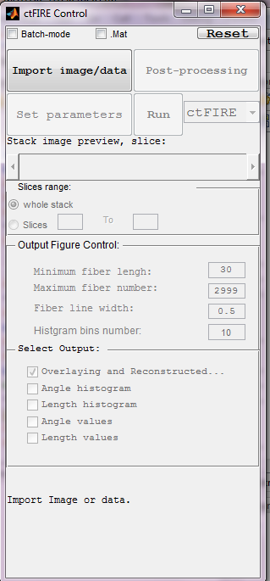

where the following list describes the function of each of the buttons and controls:

**Batch-mode**: checked to import multiple images or data.

**.mat**: checked to import the previous fiber extraction results and parameters saved in the format of ".mat " files.

**Reset**: rerun the GUI.

**Import Image/data**: import the information about an image, an image stack , or ".mat" files or multiple images, or ".mat" files when batch-mode is selected.

**Set parameters**: set fiber extraction parameters and curvelet transform based reconstruction parameters when run mode ctFIRE is selected. Detailed description about these parameters can be seen in Tutorial 1 in section 4 of this manual.

**Run**: select run mode among FIRE, ctFIRE and both FIRE and ctFIRE. Default run mode is ctFIRE.

**Post-processing**: after the fiber extraction of a single image or the import of ".mat" file(s) , the output setting can be configured to do post-processing.

**Stack image preview**: when a stack is opened, move the slide bar to view any selected slice in the stack.

**Whole stack:** checked to process the whole stack.

**Slices:** enter the range of the slices to be processed.

**Minimum fiber length**: only display fibers which are longer than this value, unit is in pixels, default value is 30.

**Maximum fiber number**: maximum number of fibers for the output figure(s) or statistic analysis. . If the number of the extracted fibers is larger than this value, only consider the first "Maximum number" of extracted fibers. Default value is 2999

**Fiber line width**: The line width of the extracted fibers in the overlaid image, default value is 0.5

Histogram bins number: the number of bins used in the angle and/or length histogram.

**Select Output**:

**Overlaying and reconstructed**: checked to show and save the overlaid image of the extracted fibers on the original image as well as show the CT reconstruction image.

**Angle histogram**: checked to show the figure of fiber angle histogram.

**Length histogram**: checked to show the figure of fiber length histogram.

**Angle values**: checked to save the fiber angle value into an Excel file.

**Length values**: checked to save the fiber length value into an Excel file.

default is only output " **Overlaying and reconstructed** ".

**Bottom information label**: indicate what is expected to do or the current program status.

# Tutorials

## Tutorial 1: fiber extraction and post-processing for a single image

***Step 1 open an image***: Leave the "Batch-mode" and ".mat" checkboxes unchecked. Click the "Import image/data" button, a file selection window opens allowing the user to choose the image. In this tutorial, "testimage1.tif" is selected.

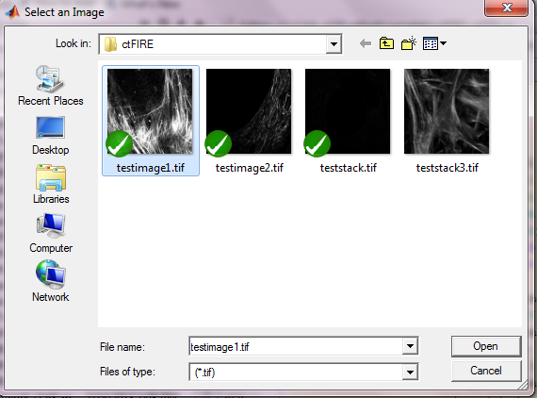

After clicking open, the image is displayed and new controls are enabled on the control panel as shown below.

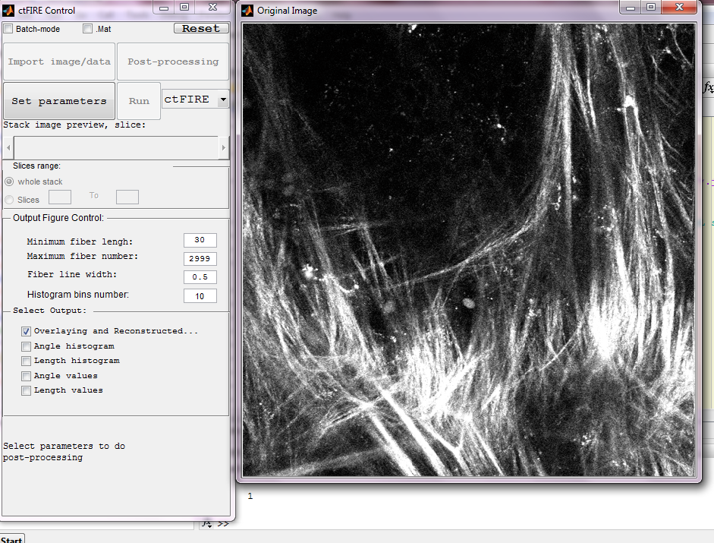

***Step 2*** ***select run mode and and set output parameters***: select the run mode on the right of "Run" button as "ctFIRE" , to run both FIRE and ctFIRE, output parameters are default values as showing in the follows:

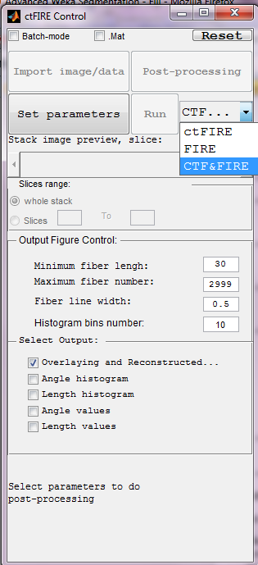

***Step 3 set fiber extraction parameters*** : click the "Set parameters" button, the following window is displayed to set 6 FIRE parameters

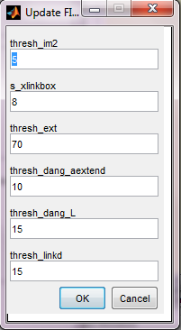

The description of the six parameters is listed below

|  |  |
| --- | --- |
| thresh_im2 | a grey level threshold value used for initially converting the image to a binary image prior to the distance transform |
| s_xlinkbox | side length of square region of pixels in which to check to determine if a pixel is a local max of the distance function |
| thresh_ext | angle similarity required for a fiber to extend to the next point |
| thresh_dang_aextend | maximum dangler angle difference at cross-link |
| thresh_dang_L | dangler length threshold |
| thresh_linkd | distance for linking similarly-oriented fibers |

Change the thresh_im2 to 30 and s_xlinkbox to 5 , click ok. Another window shown below is displayed allowing the user to set two ctFIRE parameters since the ctFIRE was selected to run in step 2.

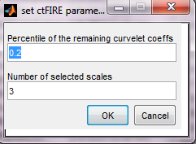

Curvelet transform denoising is performed by transforming to curvelet space, thresholding the curvelets , and then performing the inverse transform using only the selected curvelets. Here, the edit box labeled "**Percentile of the remaining curvelet coeffs**" is where the user should input the percentage of the curvelet coefficients for calculating the hard threshold applied to each scale in the inverse transformation . The edit box labeled "**Number of the selected scales**" is to set the scales to reconstruct the image. Specifically, if the total number of scales used by the curvelet transform is N and 3 is the number of selected scales in this edit box, then the actual scales used for reconstruction is scale N-1, N-2 and N-3.

In this tutorial, use the default values and click OK to continue. The button "run" is enabled.

***Step 4 run fiber extraction:***  click "Run" button. Then, the progress of fiber extraction will be listed in the Command Window. The overlaid and reconstructed images will also be displayed.

***Step 5 check the results:***

A ".mat" file containing the fiber extraction results and corresponding parameters is automatically save to a new subfolder called "ctFIREout"(if not exit, the folder will be created by ctFIRE automatically) of the folder where the image exists. In this case, the path for this subfolder is "C:\CAA_x220\github\curvelets\ctFIRE\ctFIREout" . Six output files are shown:

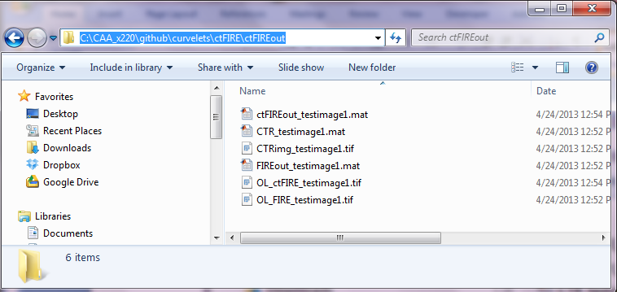

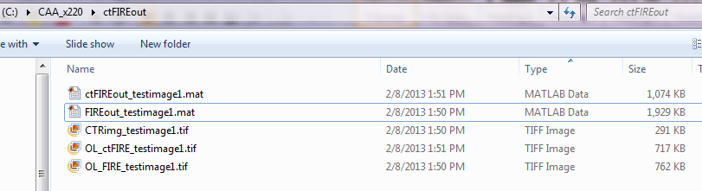

*In this calet image name =*

*FIRE output:*

FIREout_ testimage1.mat: the .mat file for the fiber extraction results by FIRE

OL_FIRE_ testimage1.tif : the .tiff overlaid image of FIRE

*ctFIRE output:*

ctFIREout_ testimage1.mat: the .mat file for the fiber extraction results by ctFIRE

OL_ctFIRE_ testimage1.tif : the .tiff overlaid image of ctFIRE

CTRimg_ testimage1.tif: the .tiff CT reconstruction image

CT_ testimage1.mat: the .mat CT reconstruction image

The three images are shown below:

CTRimg_testimage1.tif

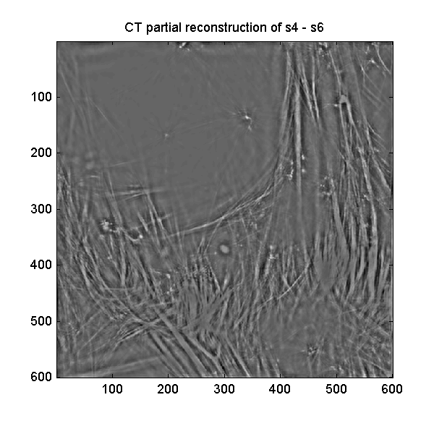

OL_ctFIRE_testimage1.tif

OL_FIRE_testimage1.tif

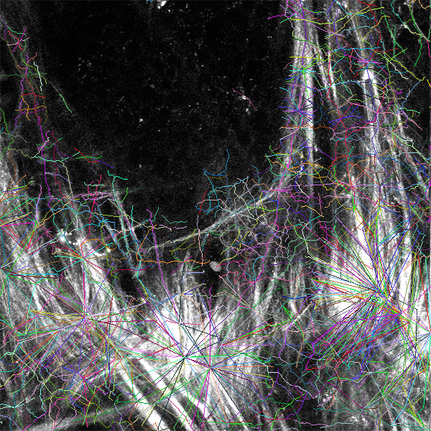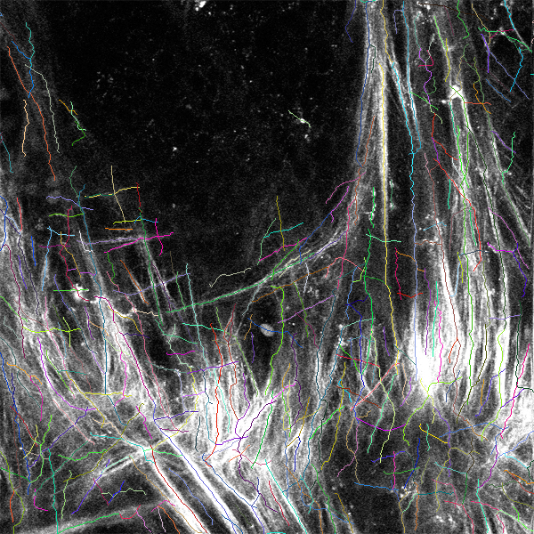

As shown above, for this test image, the results of ctFIRE look much better than those of the FIRE.

***Step 6 post-processing***: Let's suppose we are satisfied with the overlaid image, now we want to see the angle and length histograms and save the correspond values. In the control panel, the corresponding settings are:

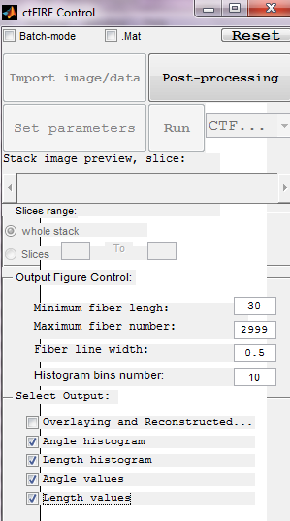

Click Post-processing, then shows:

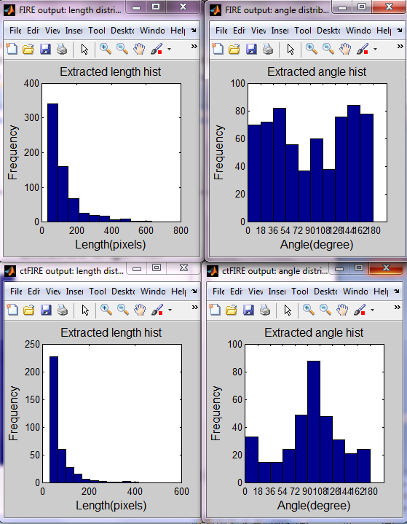

In the output folder "C:\CAA_x220\github\curvelets\ctFIRE\ctFIREout", 4 additional output files are highlighted as shown below, containing the angle and length values of both FIRE and ctFIRE.

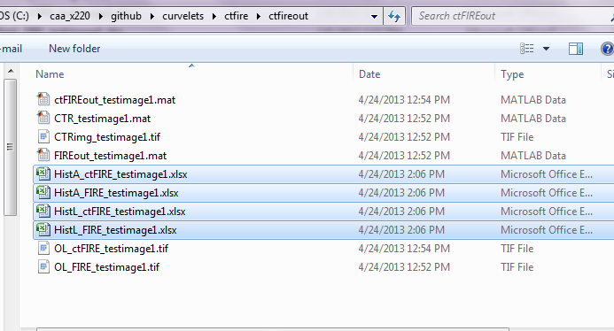***Step 7 reset the GUI***: reset to import new image or data .

## Tutorial 2: fiber extraction for an image stack

## Tutorial 3: fiber extraction for multiple images

## Tutorial 4: post processing for a ".mat" file

References:

[1] “curvelet toolbox,” <http://www.curvelet.org/software.html> (19 July 2012).

[2] A. M. Stein, D. A. Vader, L. M. Jawerth, D. A. Weitz, and L. M. Sander, “An algorithm for extracting the network geometry of three-dimensional collagen gels,” *Journal of Microscopy* **232**(3), 463–475 (2008) [doi:10.1111/j.1365-2818.2008.02141.x].